Report: MAD Project

Rollnumbers: 21SW030 (Mehak Nizamani)

21SW069 (Noor un Nisa)

Submitted to: Ma`am Maryam

Date: 25/10/2024

**Real World Problem Identification:**

Students struggle with motivation and understanding of complex subjects due to a lack of interactive and engaging learning materials and proper guidelines. So we have made an app for this Problem.

**Proposed Solution:**

We`ve made an app which is engaging, helping students to grasp difficult concepts more easily, as Many students lack access to high-quality educational materials so our app provide hand to hand material to learn from and a tracking system to track the learning.

**Responsive User Interfaces:**

We have made responsive for mobile and web.

For web:

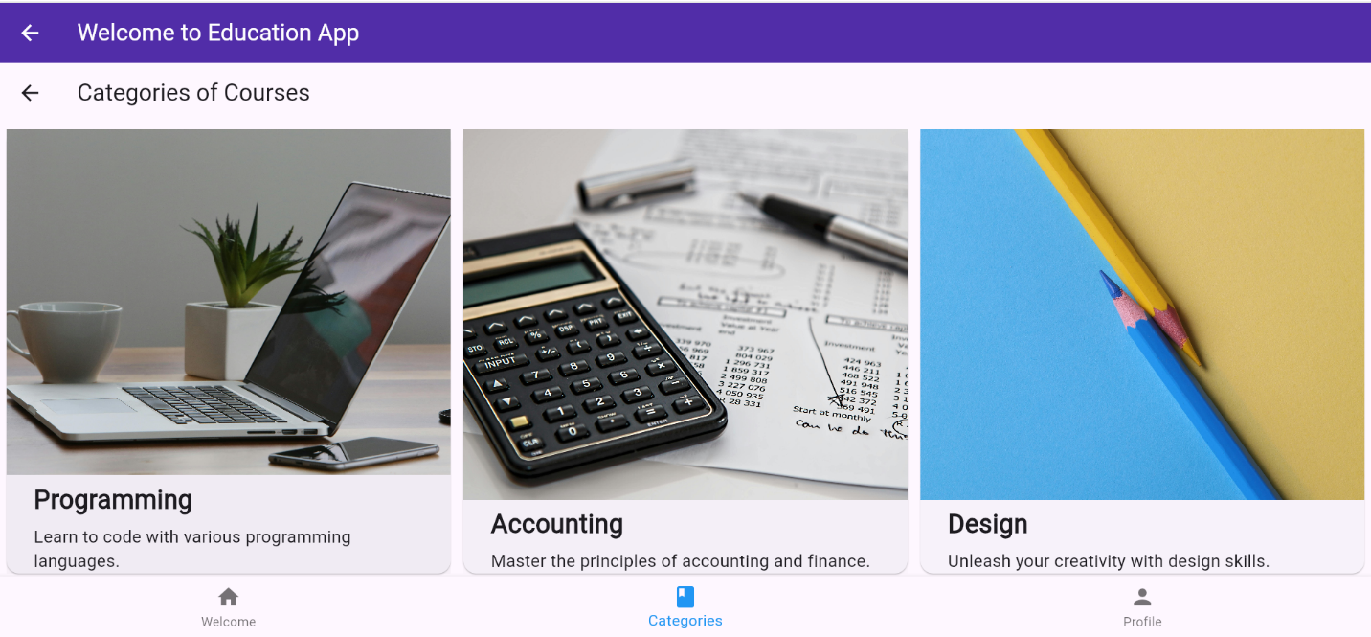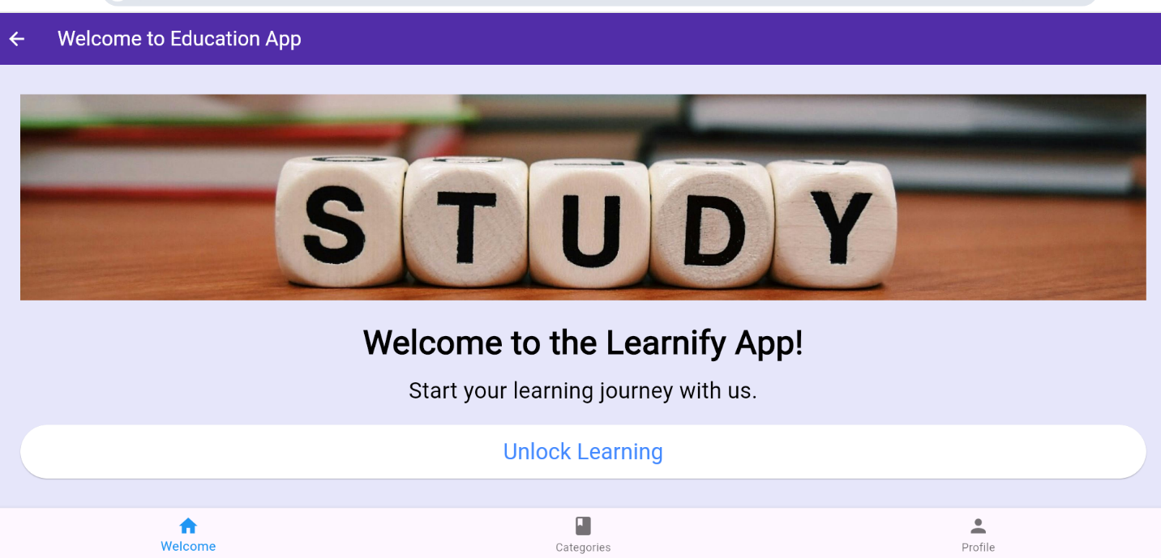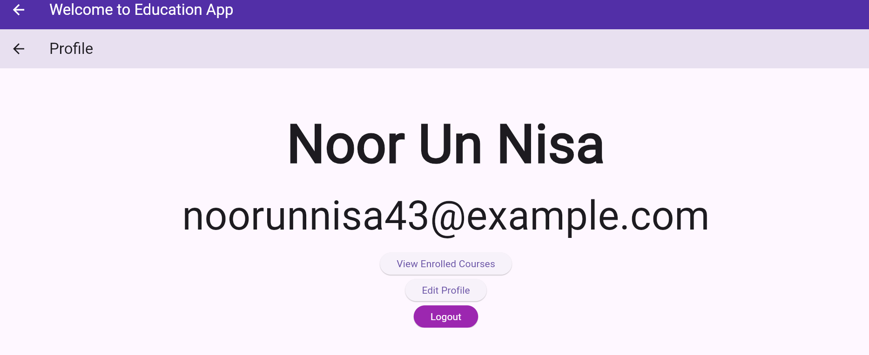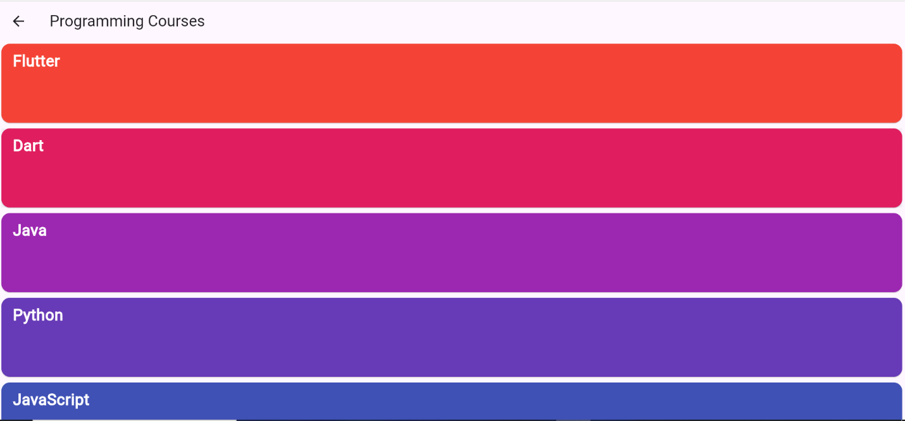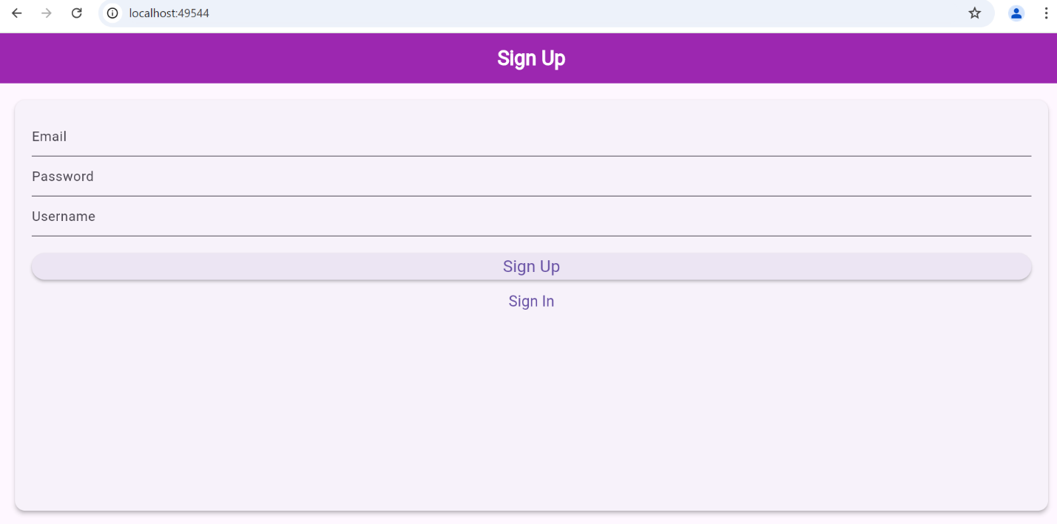

For Mobile:

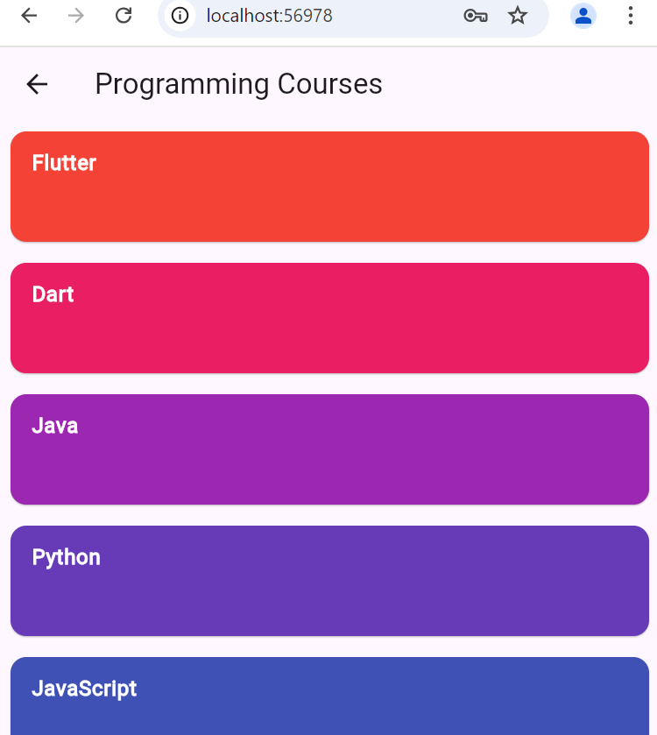

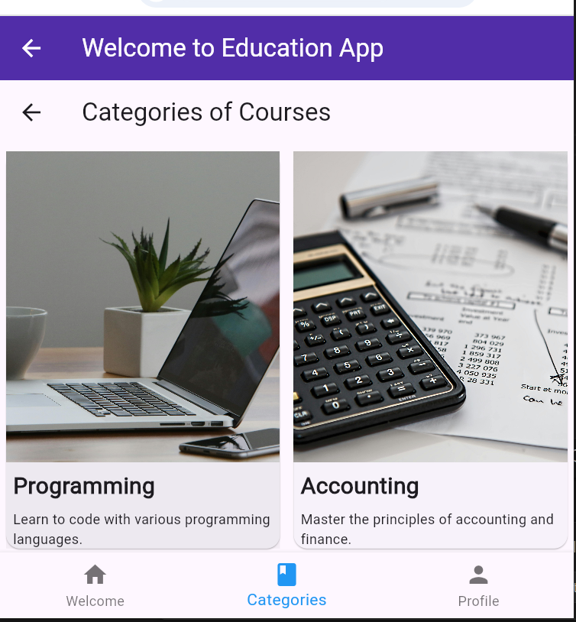

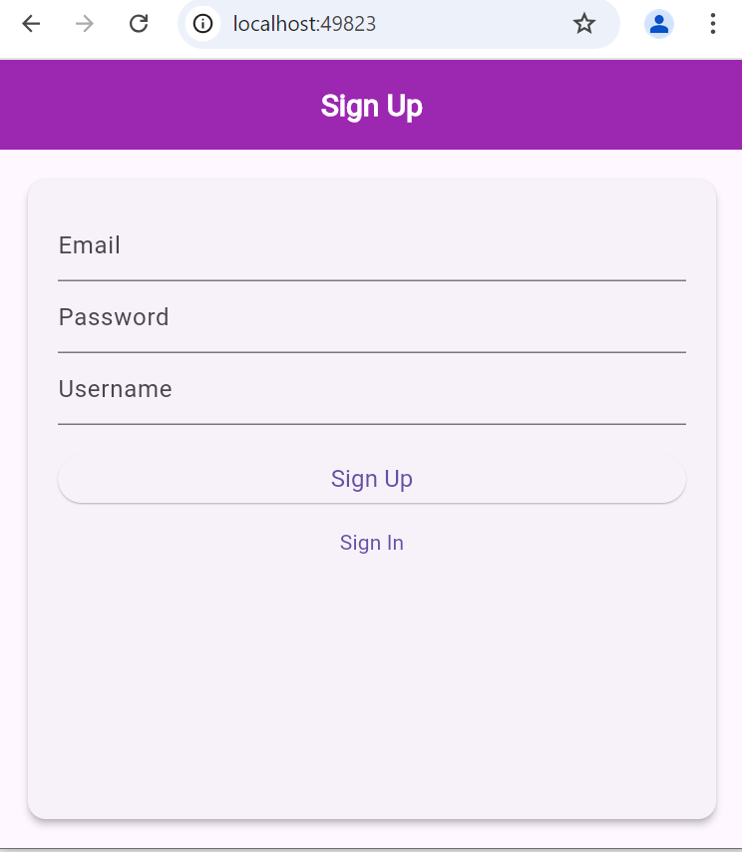

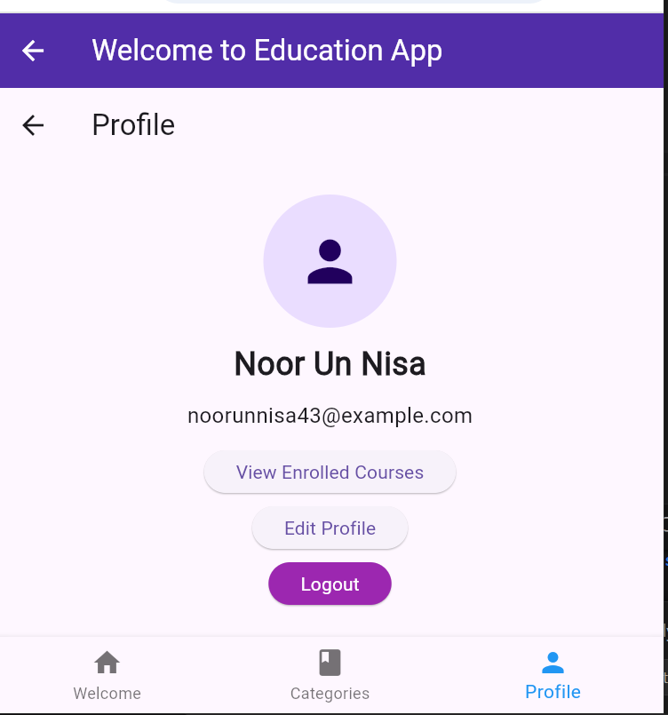

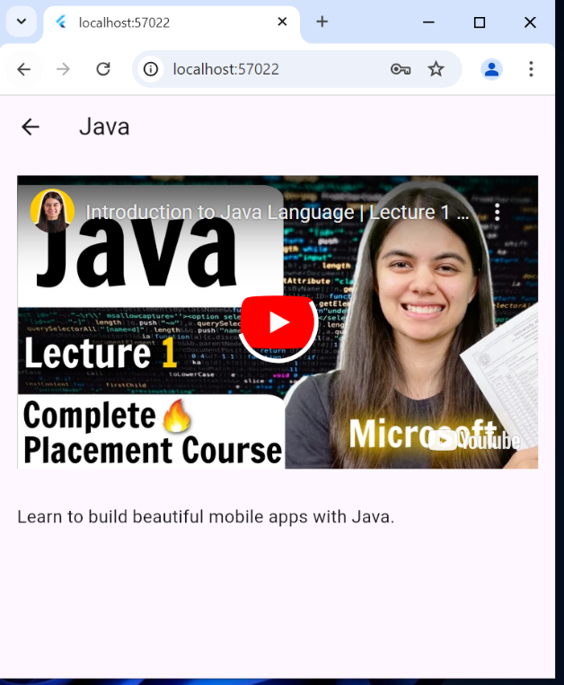

**Data Storage:**

as our app grows and attracts more users, Firebase can effortlessly handle increased traffic. This means our app can evolve without worrying about backend limitations and With Firebase Authentication, we can easily manage user accounts for students. We can create a flexible database structure to manage courses and assignments, Easily host educational resources (like videos or PDFs) and Cloud Storage for user-generated content, ensuring everything is accessible and organized.

Firebase Authetication:

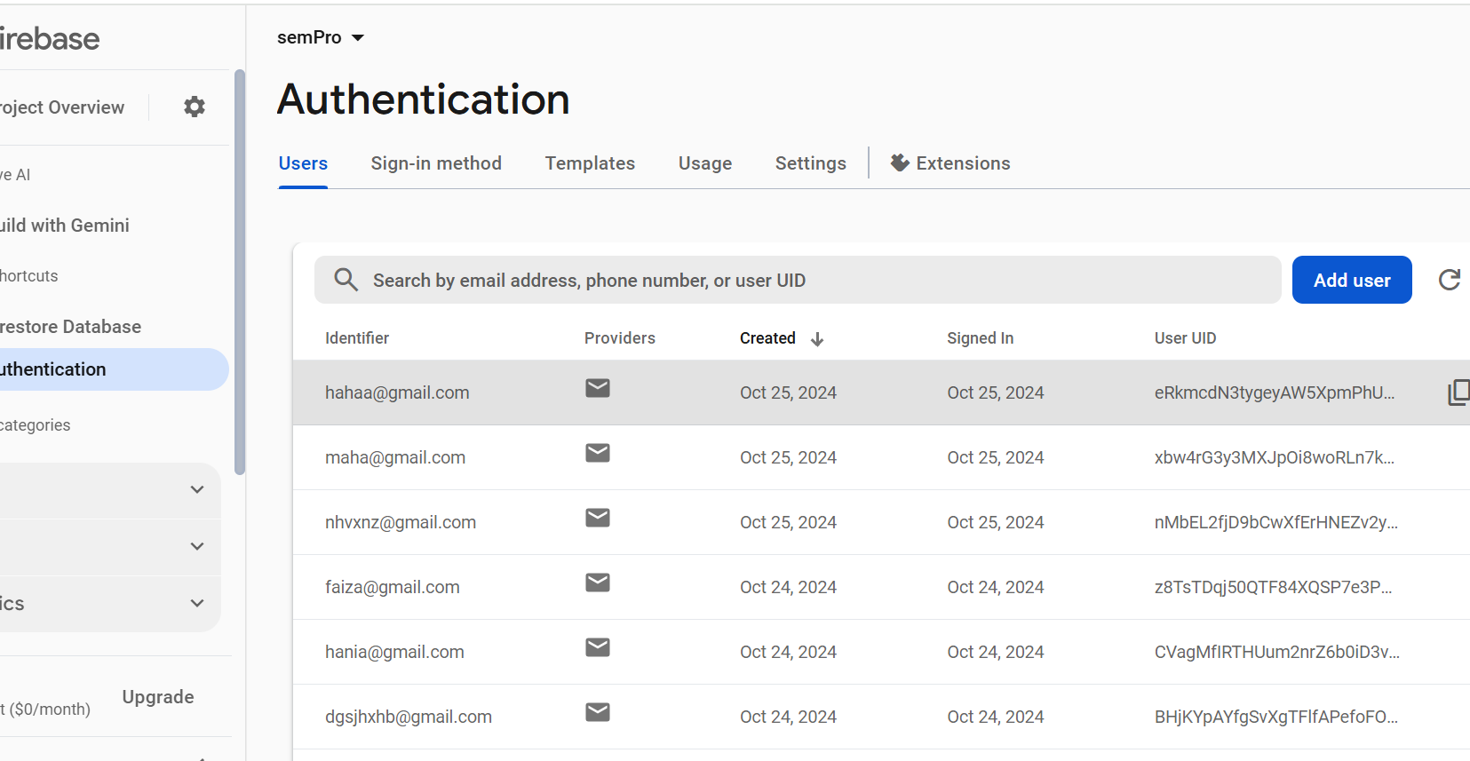

Cloud Storing:

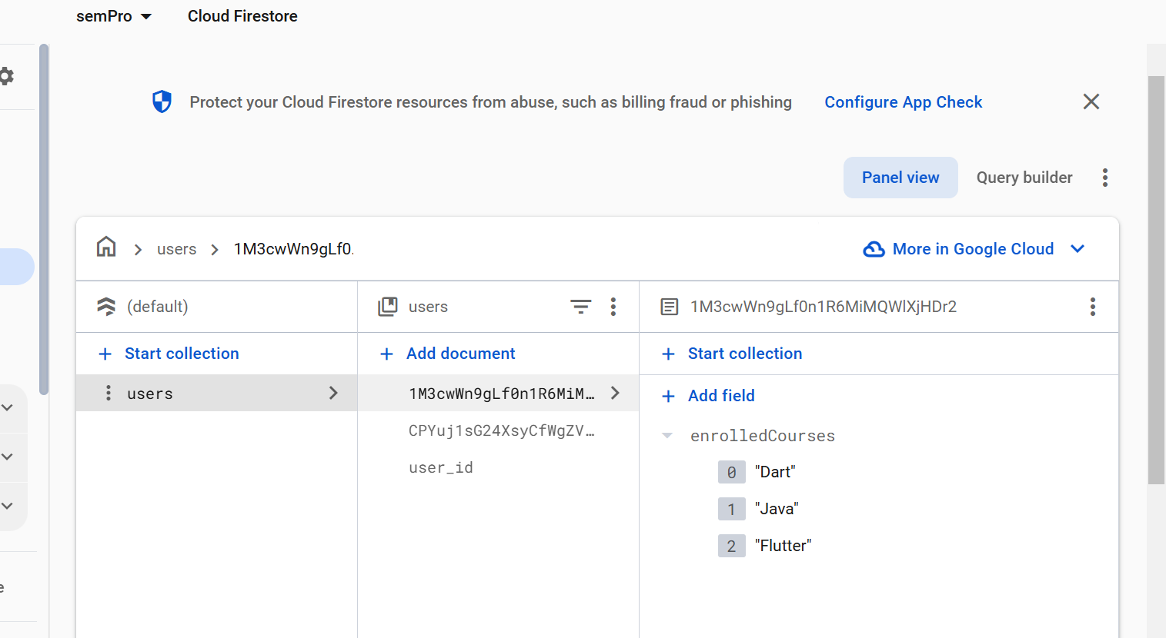

**[Optional Section] APIs/Packages/Plug-ins:**

We have used these packages in our app:

**video_player: ^2.9.2**

It provides a way to play local and network videos in our app.

**youtube_player_flutter: ^9.1.1**

Integrates YouTube videos, allowing playback directly within app.

**firebase_auth: ^5.3.1**

For authentication of users

**firebase_core: ^3.6.0**

For Initializing Firebase services Flutter app

**cloud_firestore: ^5.4.4**

For Enabling real-time database functionality for storing and retrieving data.

**webview_flutter: ^4.10.0**

It allows to embed web content within your Flutter application.

**Issues and Bugs Encountered and Resolved during Development:**

We made many errors but forgot to capture except these two:

Error 1:

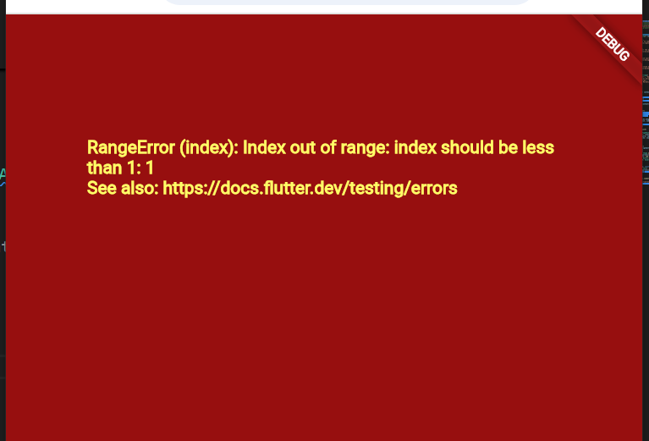

Solved by:

Proper navigating from homescreen to another screen by building constructor and pushing properly.

Error 2:

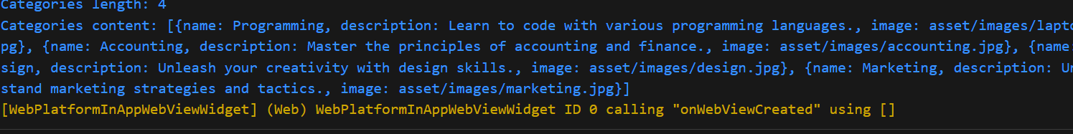

Solved by:

Code: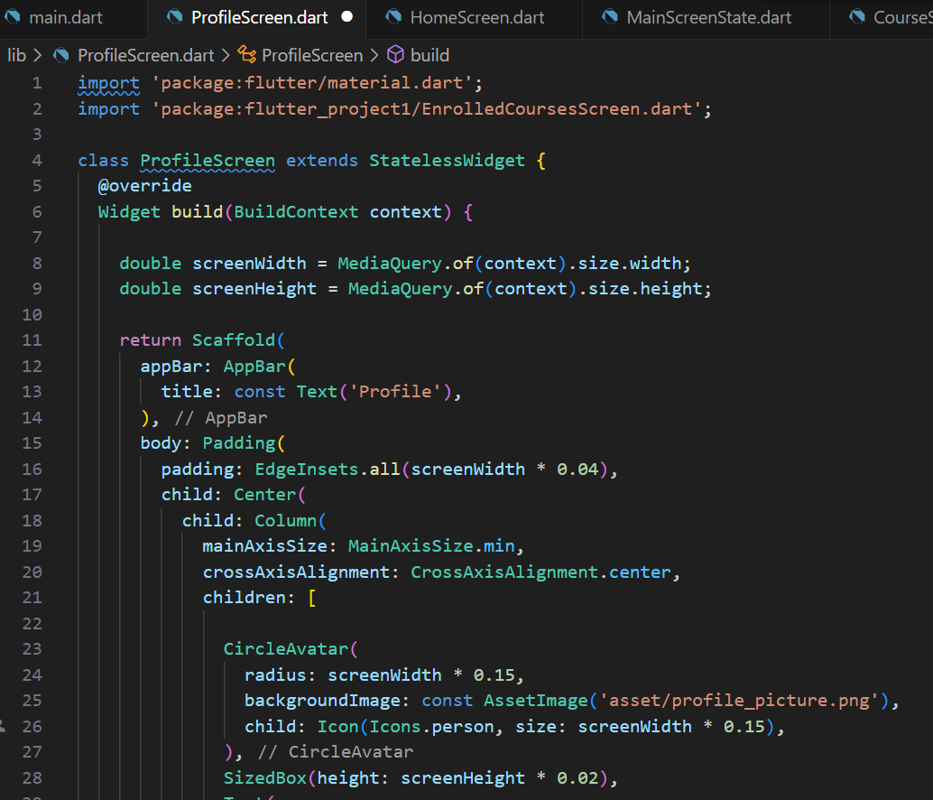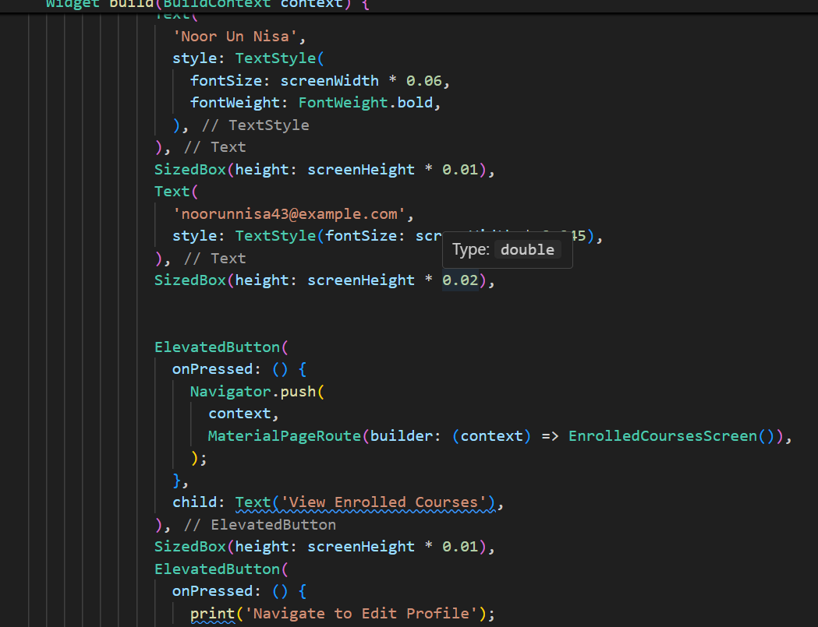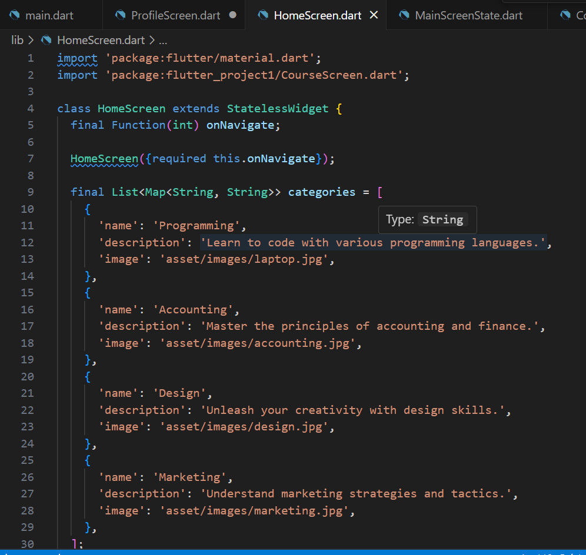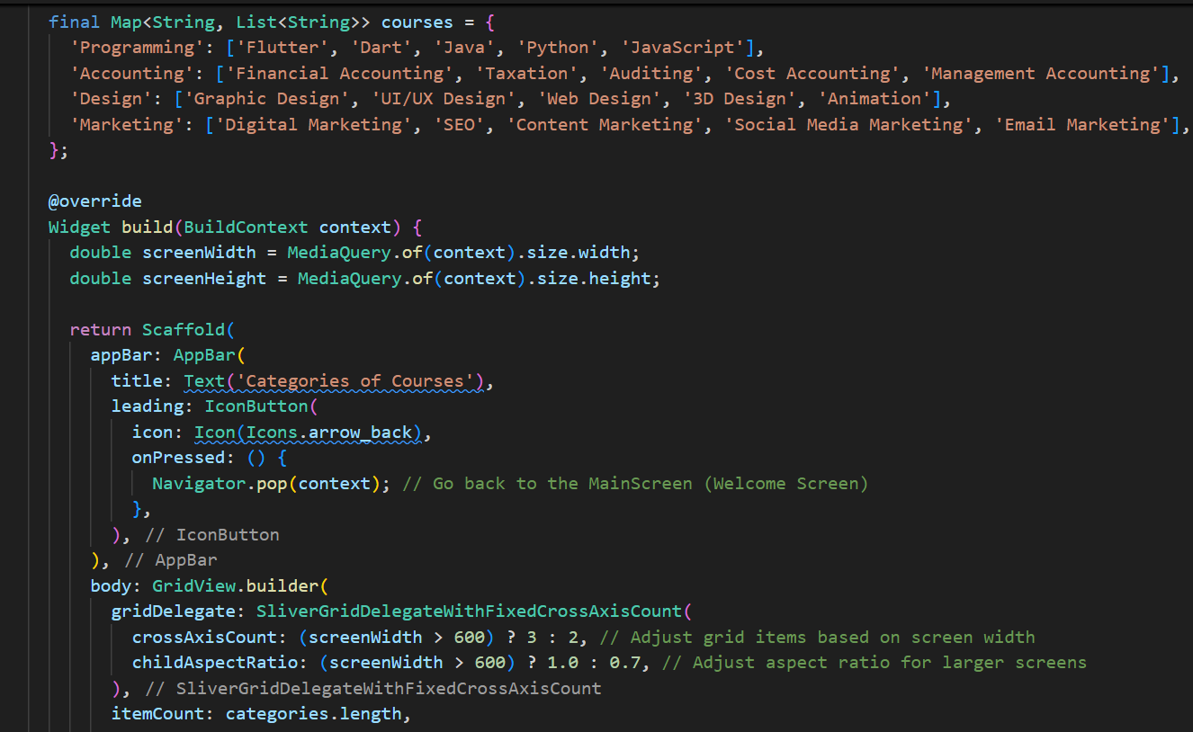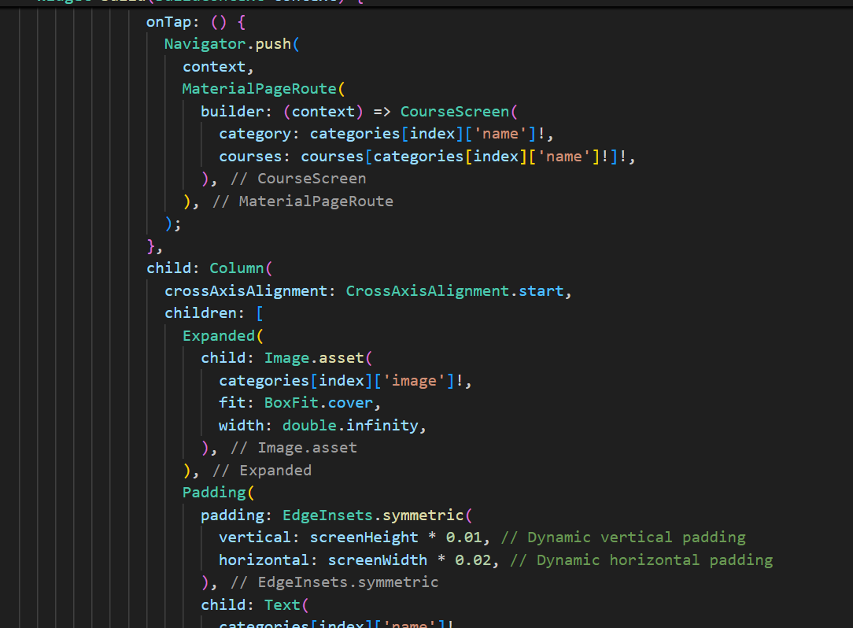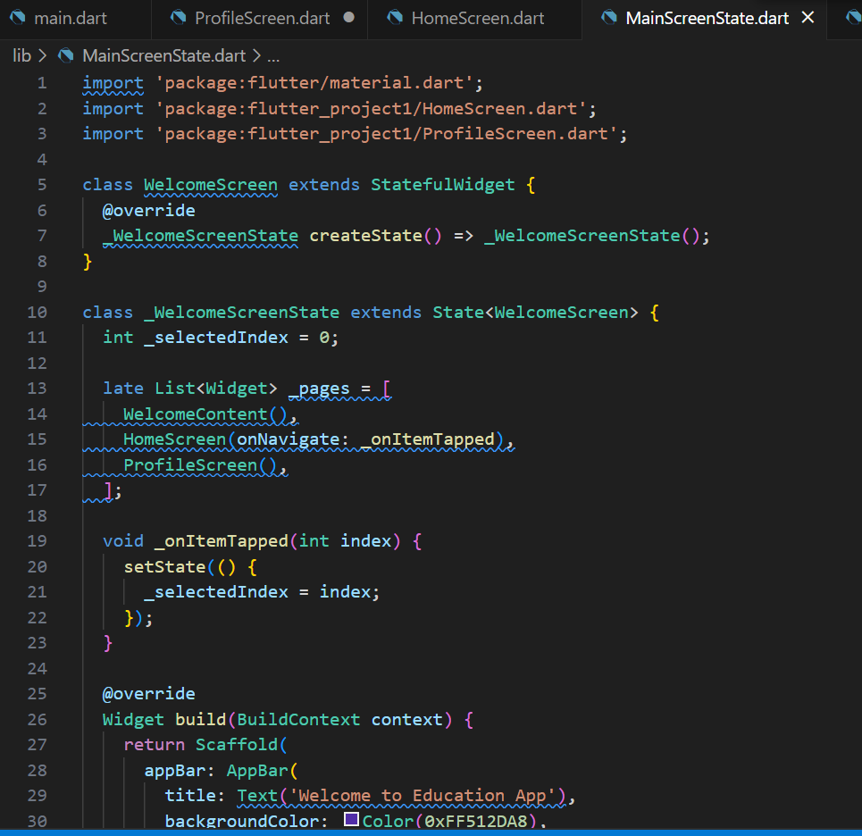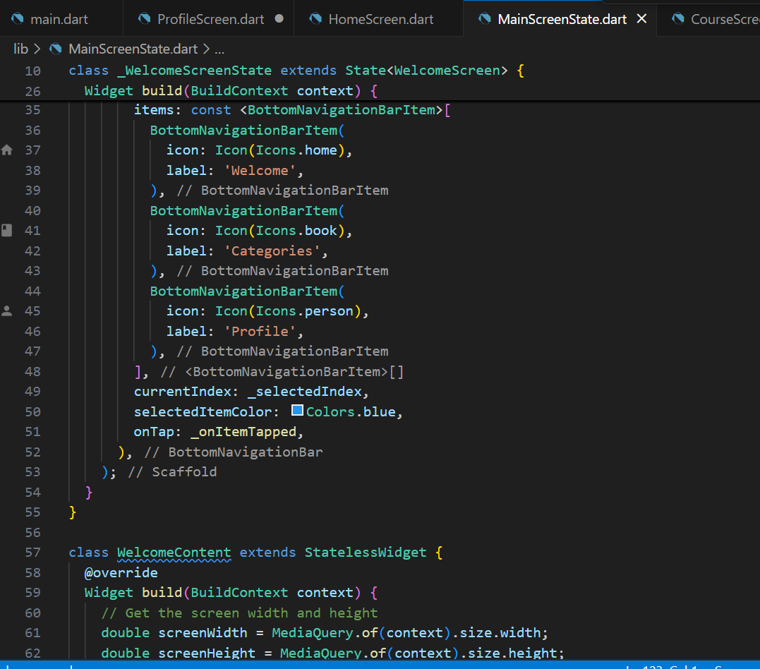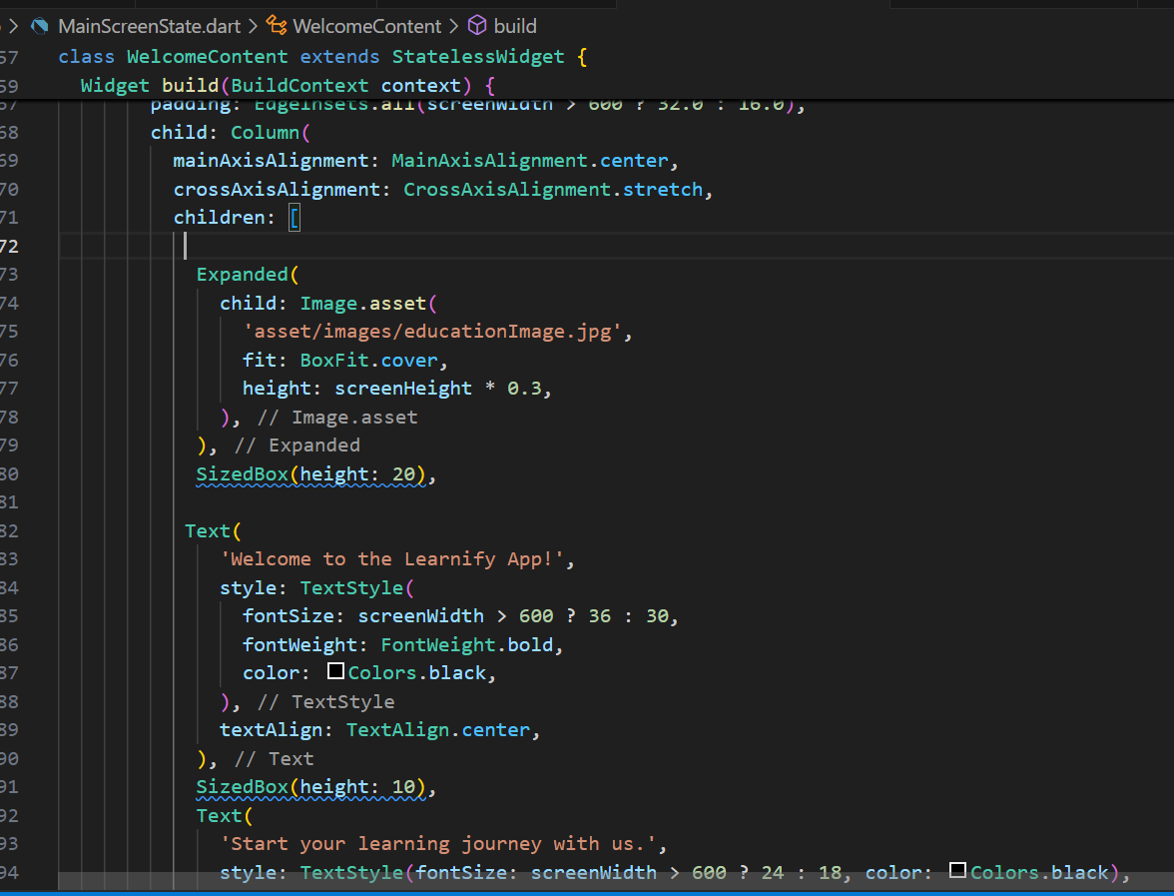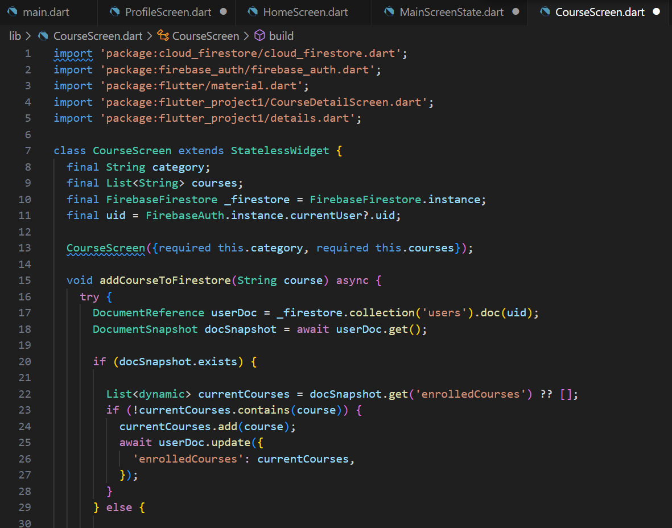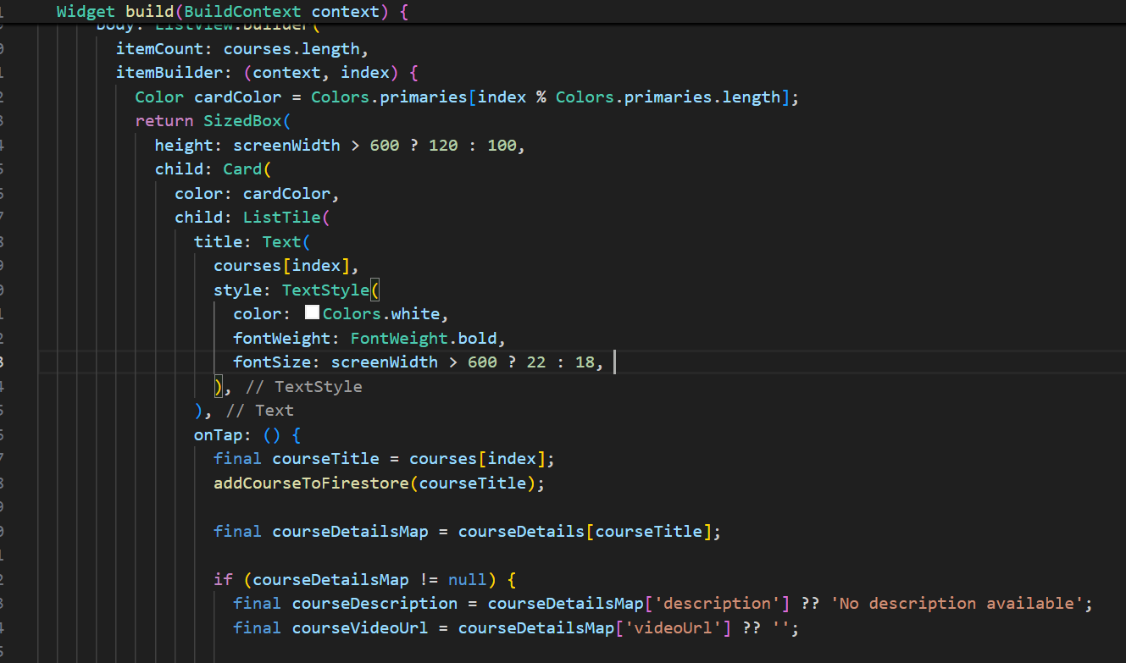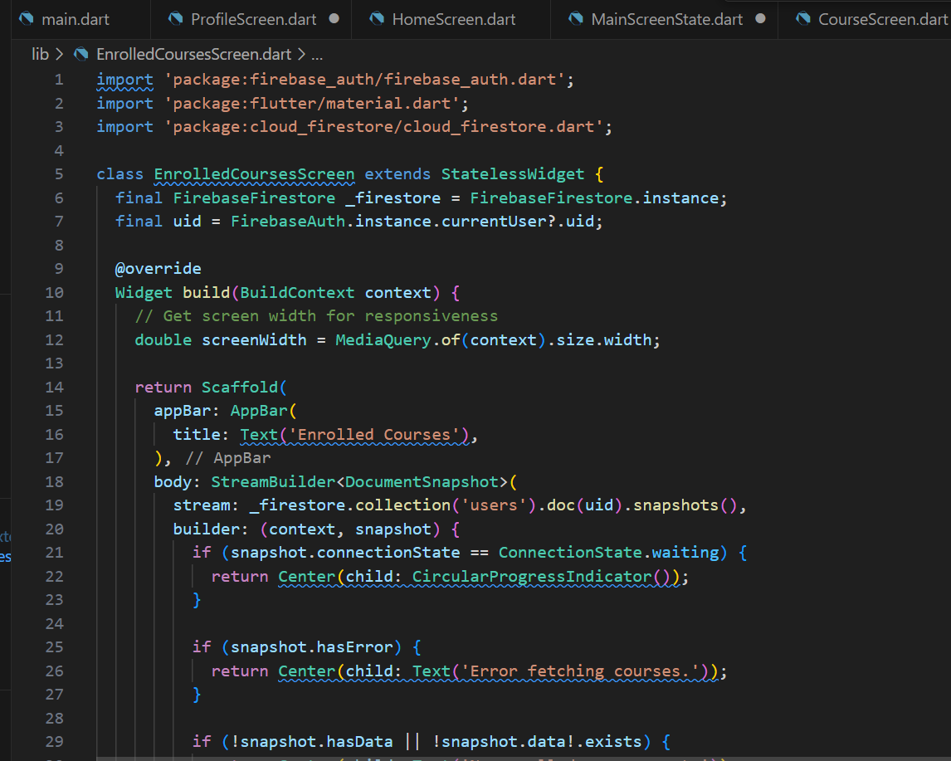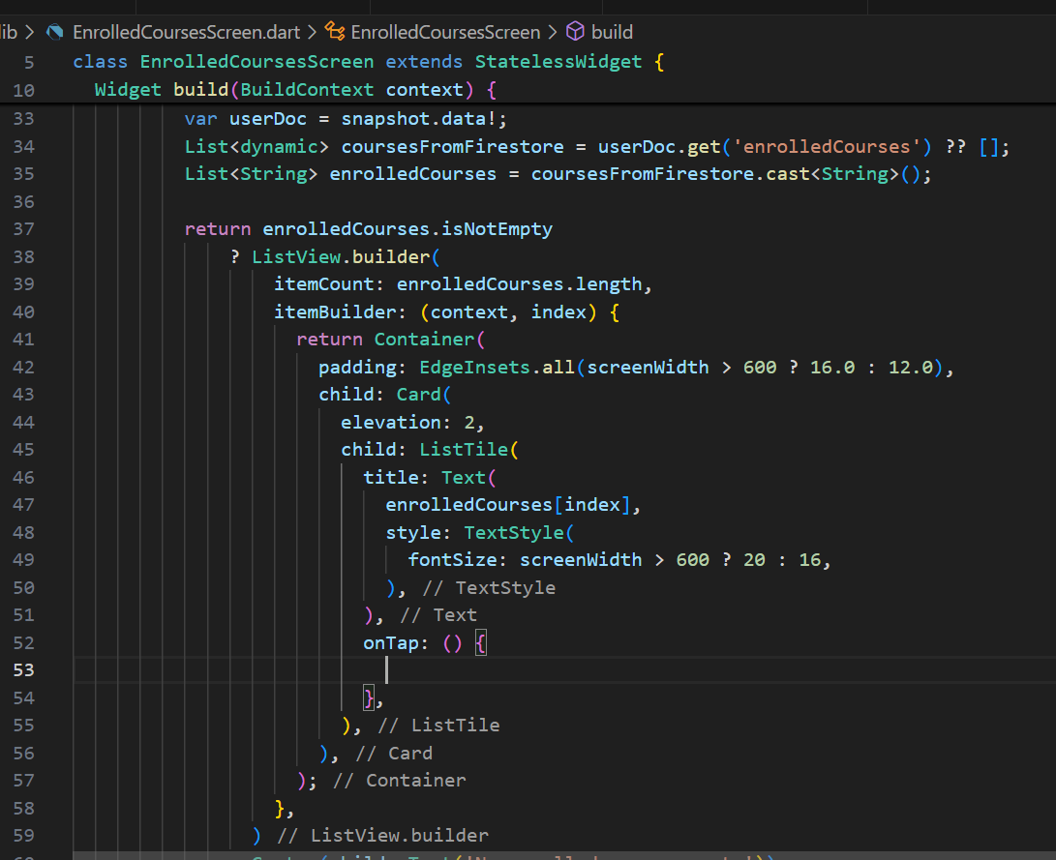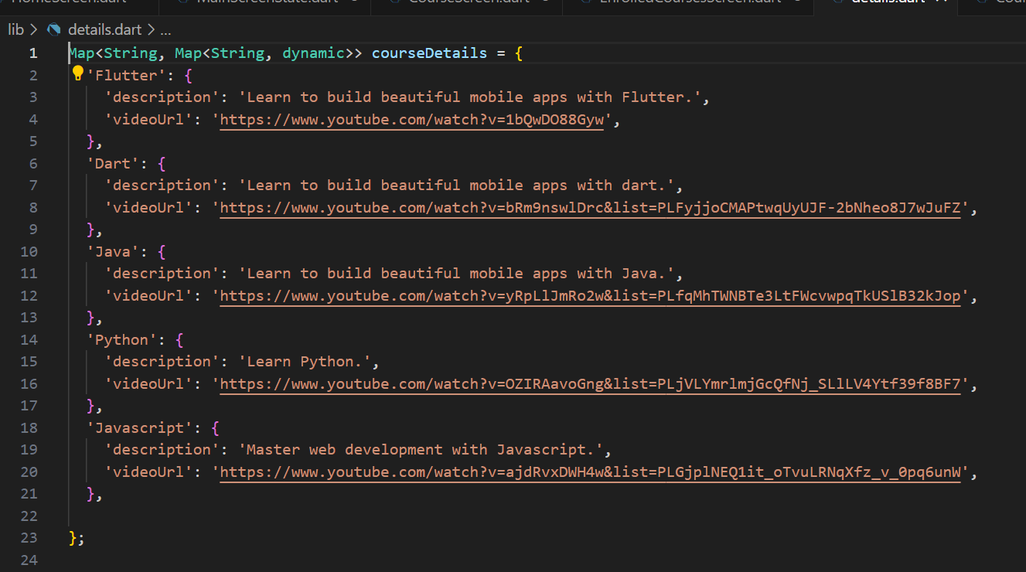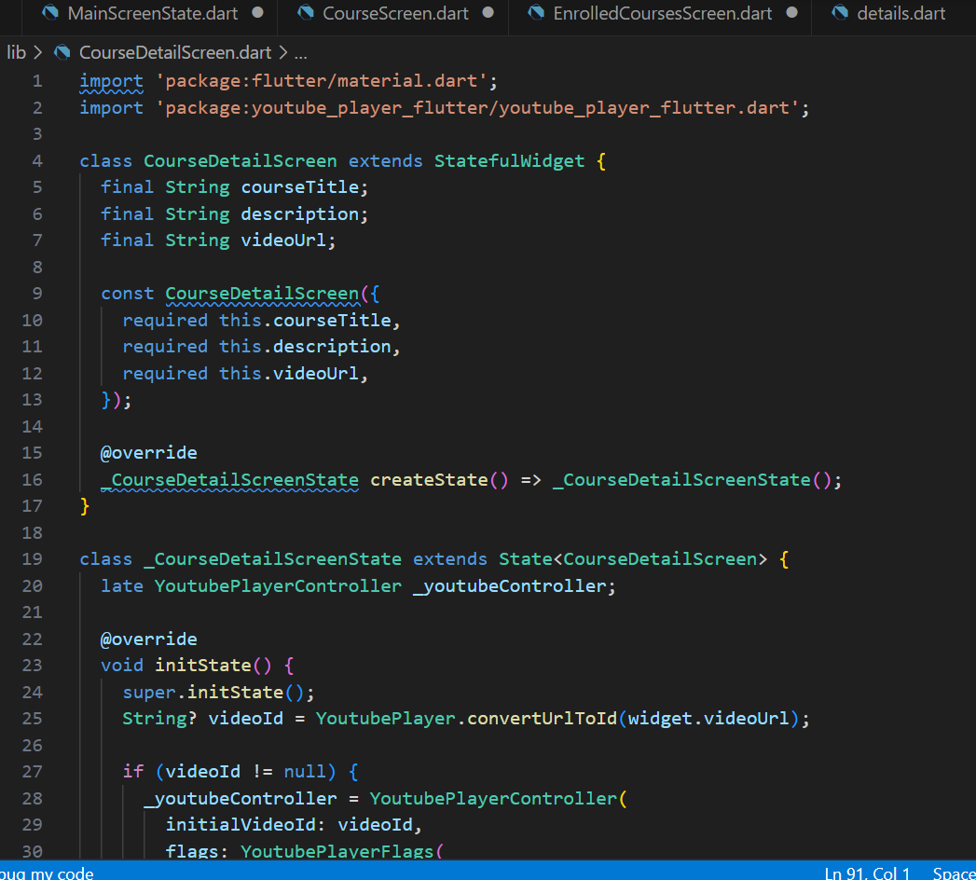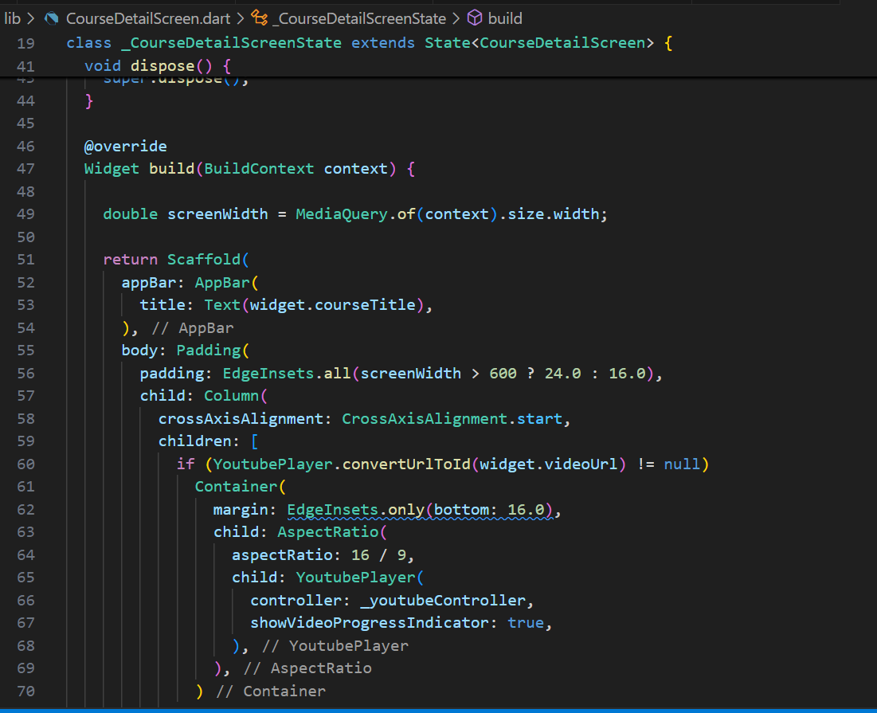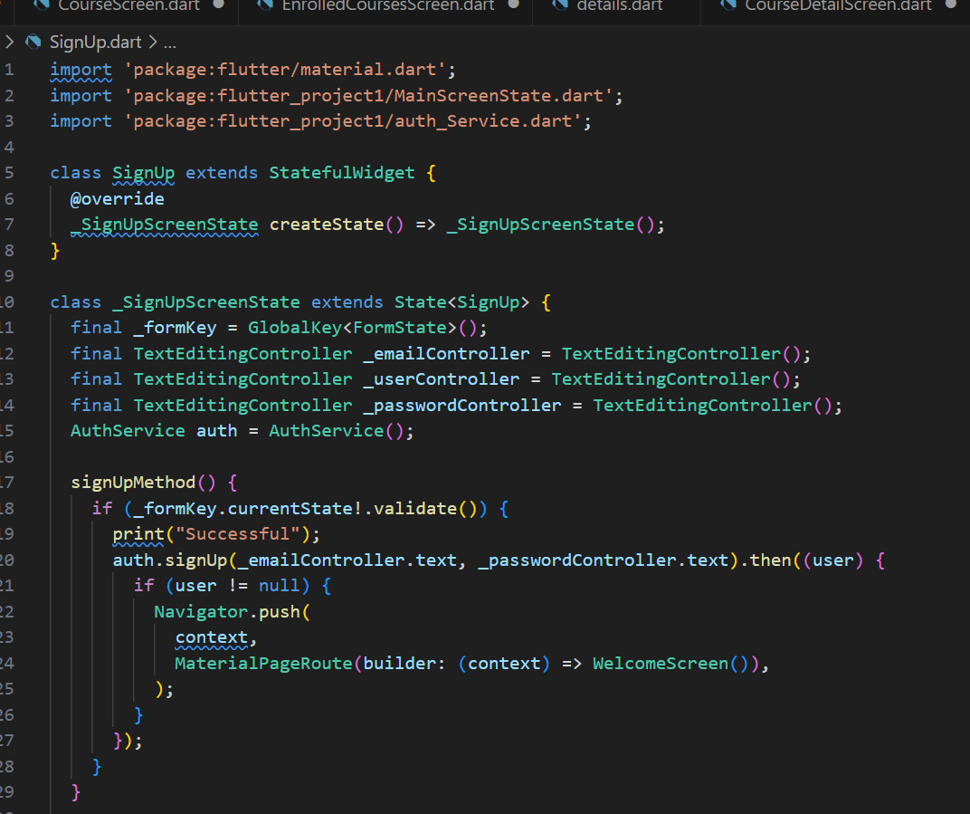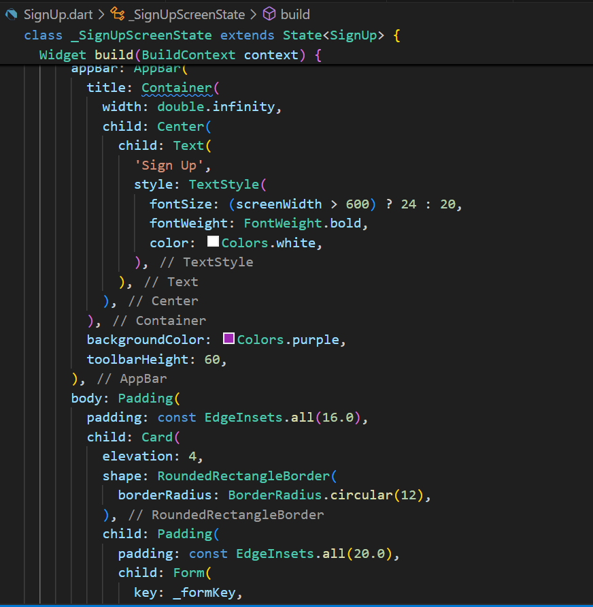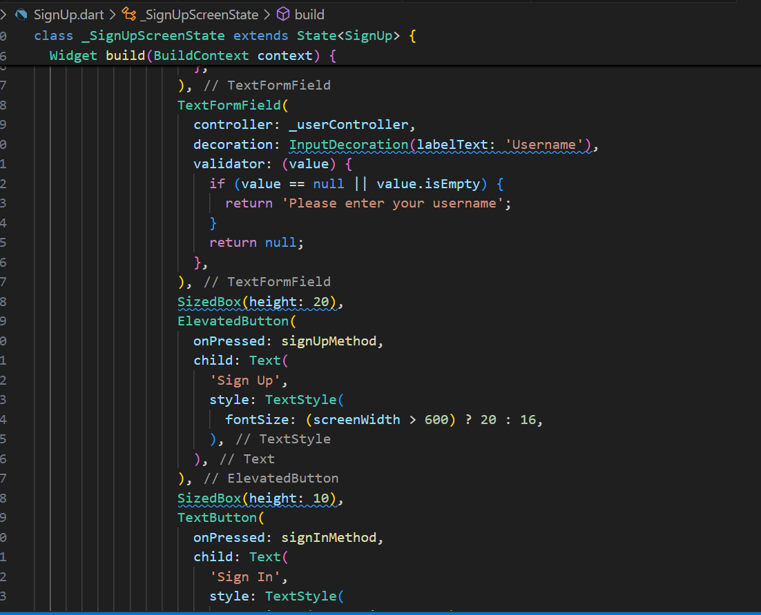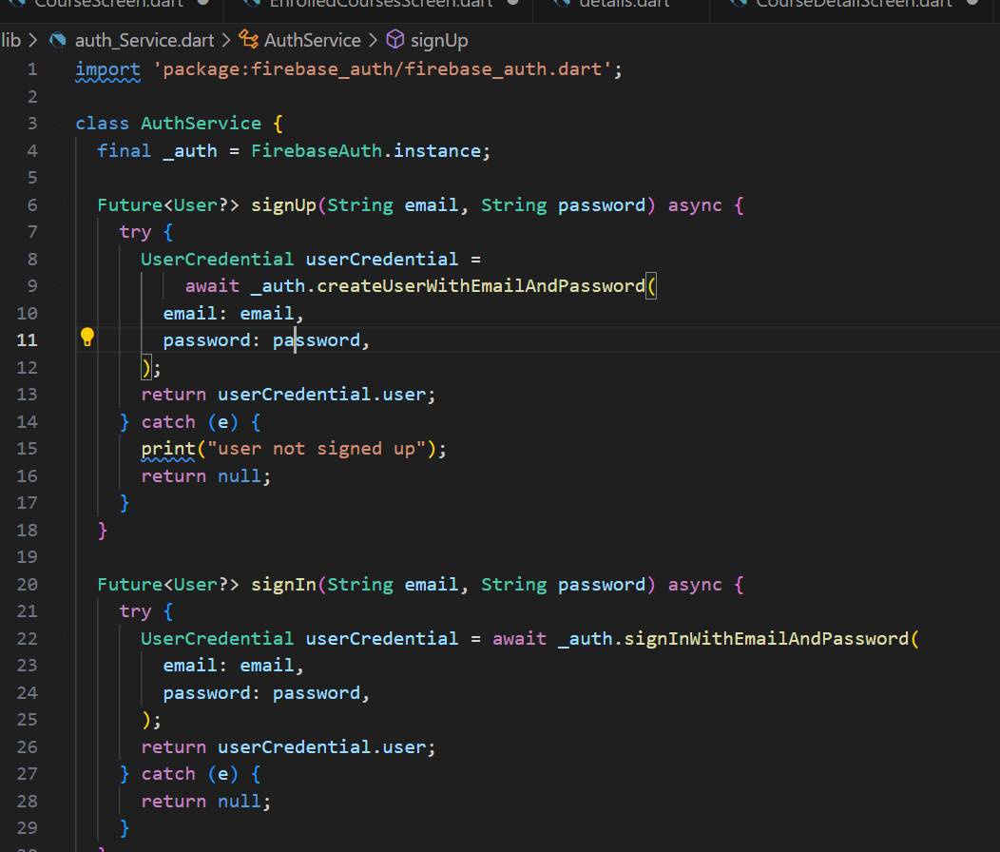

----------End-----------